#### Lightweight CNN-Based Hydrophobicity Classification of Composite Insulators for TinyML Deployment

#### A Report Submitted

#### For Term Project/Lab-based Project for the Degree of

**Master of Technology In**

**Next Generation Communication and Networks**

***Submitted by***

**Satarupa Das**

(Roll Number: 24EC4305) ***Under the Supervision of* Dr. Suman Samui**



**ELECTRONICS AND COMMUNICATION ENGINEERING DEPARTMENT**

**National Institute of Technology Durgapur West Bengal – 713209**

**India May, 2025**



**Department of Electronics and Communication**

**National Institute of Technology Durgapur**

**Mahatma Gandhi Avenue, Durgapur-713209 West Bengal**

**India**

**CERTIFICATE OF RECOMMENDATION**

This is to recommend that the work undertaken in this project report entitled, “**Lightweight CNN-Based Hydrophobicity Classification of Composite Insulators for TinyML Deployment”** has been carried out by **Satarupa Das** bearing Registration Number: 24P10115, Roll Number: 24EC4305 under my supervision and may be accepted in partial fulfillment of the requirements for the degree of Master of Technology in Next Generation Communication and Networks. She has carried out good work and has completed the project work successfully.

……………………………………. …………………………………….

Supervisor PG Coordinator

**Dr. Suman Samui Dr. Sujit Kr. Mandal**

Assistant Professor, Assistant Professor,

Electronics and Communication Engineering Department, Electronics and Communication Engineering Department,

National Institute of Technology Durgapur National Institute of Technology Durgapur

ABSTRACT

Composite insulators are critical components of high‑voltage transmission systems, relying on surface hydrophobicity to prevent leakage currents and flashovers. This work presents a lightweight CNN‑based approach for automated hydrophobicity classification (HC1–HC7) of insulator surfaces, tailored for TinyML deployment on resource‑constrained microcontrollers. Using a dataset of spray‑tested insulator images, we evaluated and optimized several compact CNN architectures (e.g., MobileNetV2, Efficient Net‑Lite) via transfer learning, followed by pruning and 8‑bit quantization. Models were benchmarked for inference latency, memory footprint, and flash usage on typical TinyML boards. Our final model achieves over 90% accuracy with sub‑100 KB SRAM usage and real‑time inference (<100 ms), enabling on‑device prediction in field‑deployed drones or IoT sensors without cloud connectivity. This solution facilitates fast, privacy‑preserving, and cost‑effective insulator monitoring, supporting proactive maintenance and grid reliability.

|  |
| --- |
| Contents: Page  1.Abstract………………………………………..iii  2.Introductin……………………………………..1  3.Background topics……………………………..2-7  4. Dataset………………………………………...7  5. Proposed Design………………………………7-9  6. Model Training………………………………..9  7. Model Evaluation……………………………..10  8. Result Analysis………………………………..10  8. Conclusion…………………………………….11  9. Future Scope…………………………………..11 |
|  |

INDEX

**Introduction**

1. **Introduction**

Composite insulators are widely used in modern power transmission systems due to their lightweight structure, high mechanical strength, and excellent performance in polluted environments. A key property influencing their performance is surface hydrophobicity, which determines the ability to resist water film formation and prevent electrical discharges. Over time, environmental stressors such as pollution, UV radiation, and aging can degrade this hydrophobicity, increasing the risk of leakage currents and flashovers.

Manual inspection of insulator surfaces is time-consuming, subjective, and impractical for large-scale deployment. Automating hydrophobicity classification using computer vision and machine learning provides a scalable and efficient alternative. However, deploying such models in the field requires solutions that can run on resource-constrained, low-power devices, where TinyML (Tiny Machine Learning) plays a critical role.

This project proposes a lightweight CNN-based model to classify insulator images into hydrophobicity classes (HC1–HC7), designed specifically for TinyML deployment on microcontrollers and edge devices.

**Scope of Work:**

This project focuses on developing a **lightweight CNN model** to classify the **hydrophobicity levels (HC1–HC7)** of composite insulators using image data. The work includes preparing and preprocessing the dataset, applying **transfer learning** with efficient CNN architectures, and optimizing the models through **pruning and quantization**. The final model is deployed on **TinyML-compatible edge devices** for **real-time, on-device inference**, supporting automated and efficient field inspection.

1. **Background topics :**

Here few background topic needed to be discussed. Before discussing the main topic.

* 1. **Hydrophobicity classification:**

Hydrophobicity classification is the process of assessing how effectively a material’s surface—such as that of a composite insulator—repels water. This is typically done by observing the shape and spread of water droplets on the surface. Based on these observations, insulators are assigned to one of several standardized levels, commonly from HC1 to HC7:

* HC1: Fully hydrophobic – water forms distinct, round droplets
* HC7: Fully hydrophilic – water spreads completely, forming a continuous film

Intermediate classes (HC2 to HC6) represent varying degrees of surface degradation.

This classification is important because hydrophobicity directly impacts an insulator’s ability to resist leakage currents, especially in humid, polluted, or rainy environments. As the hydrophobic property degrades over time due to UV exposure, pollution, aging, or chemical attack, the surface becomes more prone to forming conductive water films, which can lead to flashovers and electrical failures.

By classifying hydrophobicity:

* Engineers can monitor the health of insulators
* Utilities can schedule preventive maintenance
* Risk of unexpected power outages is greatly reduced

In modern systems, this process can be automated using image classification and machine learning, allowing for real-time, objective, and remote assessment—especially useful when deployed via drones or edge AI systems.

### ****Why Hydrophobicity Classification?****

* **Prevent Electrical Failures:** Loss of hydrophobicity can lead to leakage currents and flashovers, resulting in power outages.
* **Monitor Aging & Pollution:** Over time, UV exposure, dust, and chemicals degrade the insulator surface. Classification helps monitor these effects.
* **Plan Maintenance:** Knowing the current hydrophobicity level allows timely cleaning or replacement, preventing unexpected failures.
* **Enable Automation:** With image processing and machine learning, the classification process can be automated, enabling fast, remote, and objective evaluation using drones or IoT devices.
  1. **Composite Insulator:**

A composite insulator is a modern electrical insulation device extensively used in high-voltage transmission and distribution systems. It serves the crucial function of electrically isolating live components of power lines while providing mechanical support. Unlike traditional insulators made of porcelain or glass, composite insulators are constructed using non-ceramic materials, which offer significant advantages in terms of performance, weight, and durability.

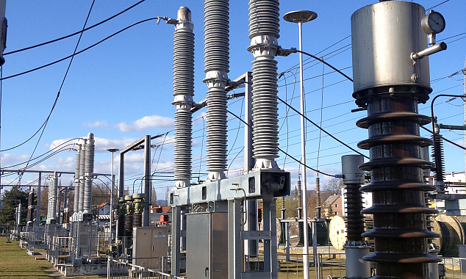The structure of a composite insulator typically includes a fiberglass-reinforced plastic (FRP) core rod, which provides the necessary mechanical strength to withstand high tensile forces. Surrounding the core is an outer housing made of silicone rubber or EPDM (ethylene propylene diene monomer). This housing acts as a weather-resistant barrier, protecting the core from moisture, UV radiation, and contamination. The silicone rubber sheath is particularly valuable due to its hydrophobic properties, which help prevent the formation of water films on the surface, thereby minimizing the risk of leakage currents and flashovers during wet or polluted conditions. Composite insulators are known for being lightweight, flexible, and resistant to breakage, which makes them easier to transport and install, especially in remote or hard-to-reach areas. They also exhibit better performance in polluted environments, as the hydrophobic surface tends to recover even after temporary loss, reducing the need for frequent maintenance. As a result, composite insulators are increasingly replacing conventional types in overhead power lines, switchgear, transformers, and railway electrification systems, offering a cost-effective, reliable, and long-lasting solution for modern power networks.

# Fig:1 Composite Insulator

**2.3 Tiny Machine Learning:**

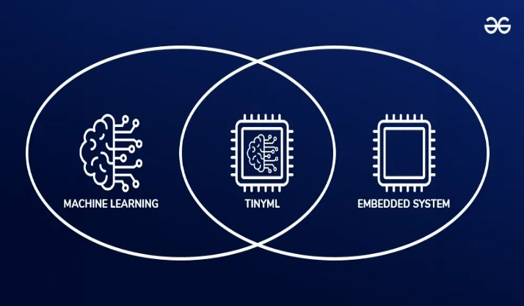Tiny Machine Learning (TinyML) is a specialized branch of machine learning focused on running AI models directly on small, low-power devices such as microcontrollers and embedded systems. Unlike traditional machine learning that relies on powerful servers or cloud computing, TinyML enables devices with limited memory, processing power, and energy resources to perform intelligent tasks locally.

# Fig:2 Tiny Machine Learning

This approach allows for real-time data processing, low latency, and enhanced privacy, as sensitive information doesn’t need to be sent to the cloud.

TinyML is especially important for applications in IoT devices, wearable technology, environmental sensors, and edge computing, where efficient, low-power, and cost-effective solutions are essential. By bringing machine learning capabilities to the edge, TinyML opens up new possibilities for smart, autonomous systems that can operate reliably even in remote or disconnected environment.

**2.3.1 Tiny Machine Learning Characteristics:**

* Low latency and real-time inference at the edge.
* Low energy consumption enables battery-operated or energy-harvesting applications.
* Privacy preservation as data processing occurs locally.
* Connectivity independence, which is ideal for remote or unreliable networks.

**2.3.2. TinyML Deployable Boards & Specs:**

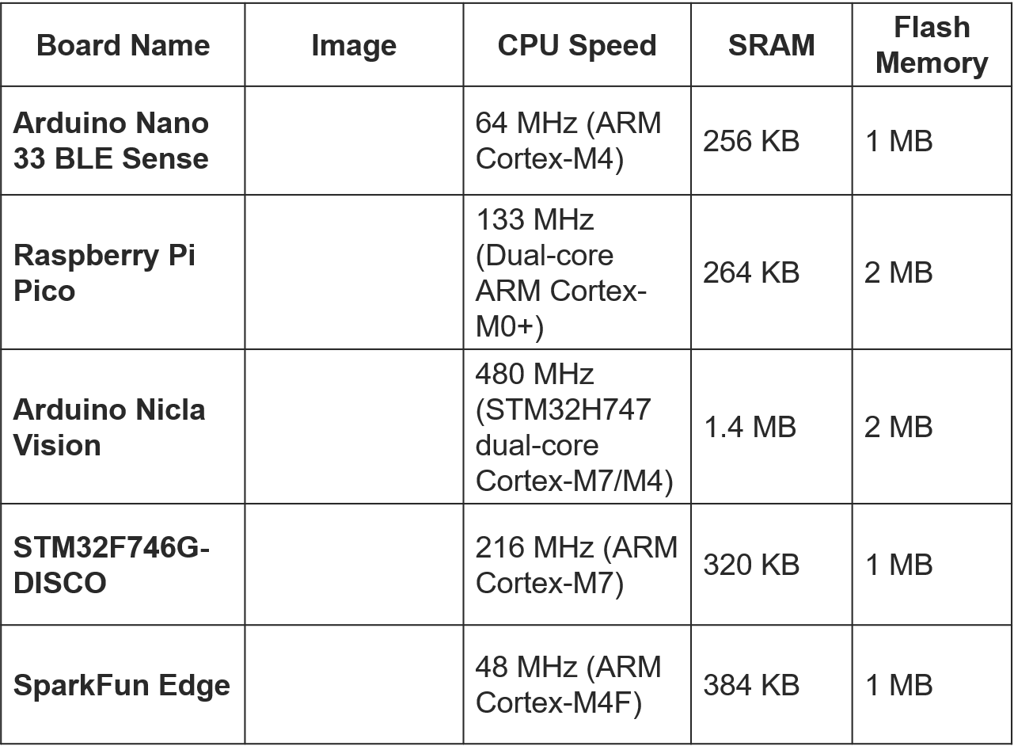

**2.4 Image Classification:**

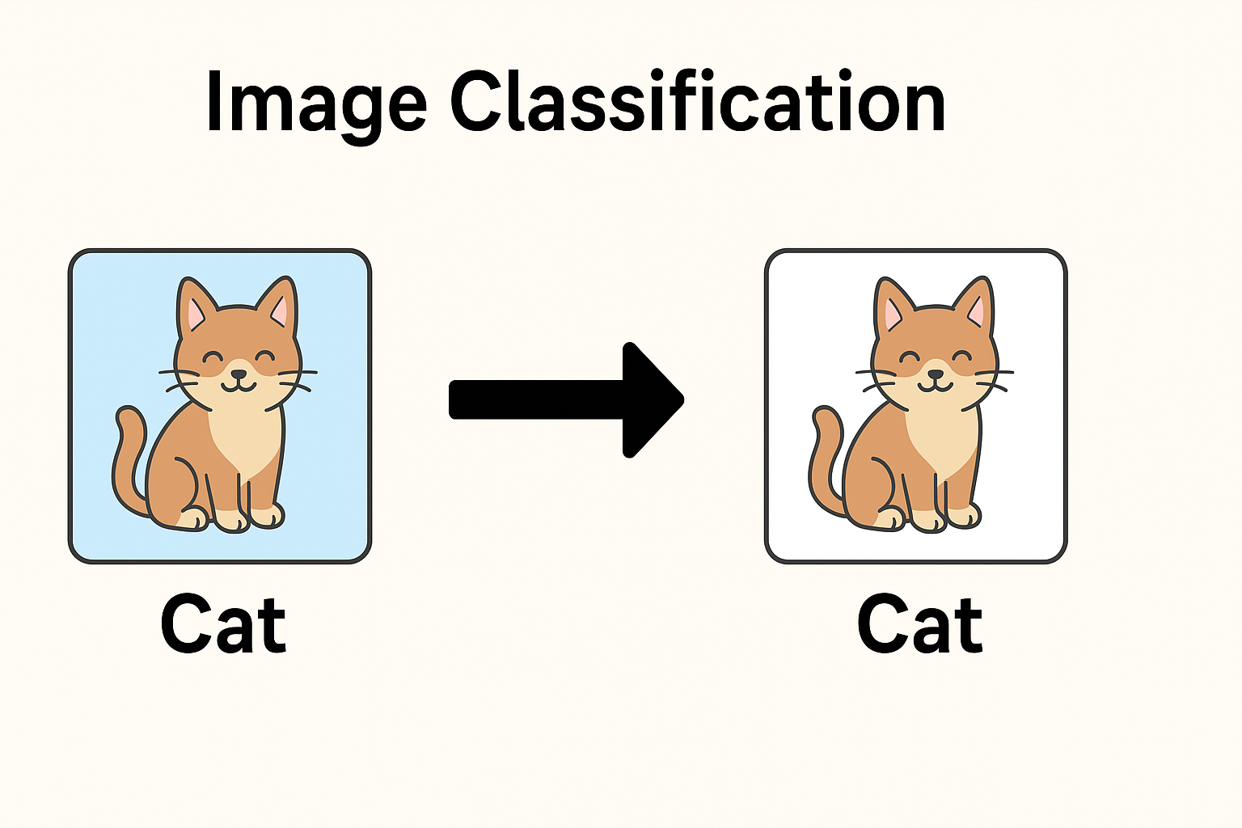**Image classification** is a fundamental task in computer vision and machine learning, where the goal is to enable a computer to **analyze an image and assign it to a specific category or label**. This process involves training a machine learning model, often a **Convolutional Neural Network (CNN)**, on a dataset of labeled images so that it can learn to recognize patterns, features, and visual cues that distinguish one class from another. Once trained, the model can then predict the class of new, unseen images with a certain level of confidence.

**Fig3: Image Classification**

For example, in a hydrophobicity classification project, an image classification model can be trained to recognize the **hydrophobic condition of an insulator's surface** by analyzing water droplet patterns in images and assigning a label such as **HC1 to HC7**. The process begins with **image preprocessing**, followed by **feature extraction**, where the model detects elements like edges, textures, and shapes. These features are then used by the neural network to make a classification decision.

Image classification is widely used in various fields, including **medical diagnosis (e.g., classifying X-rays), security (e.g., face recognition), agriculture (e.g., plant disease detection), and manufacturing (e.g., defect detection)**. In recent years, the development of **lightweight models and TinyML** has made it possible to run image classification tasks directly on edge devices, allowing for real-time, offline, and privacy-friendly applications.

**2.5 CNN:**

Convolutional Neural Networks (CNNs) are a type of deep learning model that are especially powerful for analyzing visual data like images. CNNs are designed to automatically and adaptively learn patterns and features from images using a process that mimics the way the human brain processes visual information. They are made up of multiple layers, including convolutional layers, pooling layers, and fully connected layers, which work together to extract and understand features such as edges, textures, shapes, and objects in images.

In image classification tasks, CNNs play a crucial role by first detecting low-level features (like lines or corners) and gradually learning more complex structures (like eyes, faces, or specific textures) as the image passes through deeper layers. This makes CNNs extremely effective for applications such as object detection, face recognition, medical imaging, and industrial inspection.

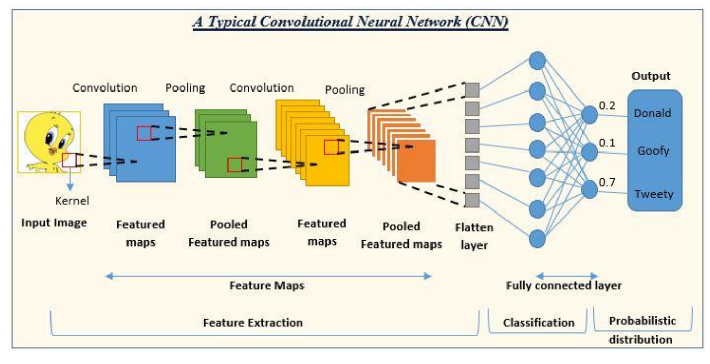In the context of hydrophobicity classification, CNNs are used to examine surface images of composite insulators and identify the water droplet patterns to predict their hydrophobic class (e.g., HC1 to HC7). CNNs are also highly suitable for TinyML applications, as they can be optimized into lightweight versions that run efficiently on microcontrollers, enabling real-time image analysis directly on low-power devices without needing internet access.

**Fig4: CNN**

**2.5** **Transfer Learning:**

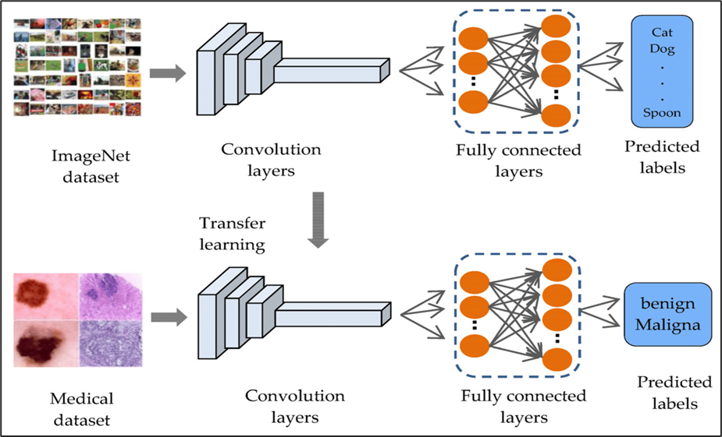**Transfer Learning** is a machine learning technique where a model trained on one task is reused for a different but related task. Instead of training a model from scratch—which requires a large dataset and significant computing resources—transfer learning allows you to **leverage a pre-trained model** that has already learned general features from a large dataset (like ImageNet), and then **fine-tune** it on your specific dataset.

**Fig4: Transfer Learning**

In image classification, transfer learning is especially useful because early layers of a pre-trained CNN already understand basic visual features like edges, shapes, and textures. These features are common across many types of images. Only the final layers need to be retrained to adapt the model to recognize new categories, such as **hydrophobicity levels (HC1 to HC7)** in insulator images.

This approach not only saves training time and computational cost, but it also **improves accuracy**, especially when working with small or specialized datasets. In TinyML projects, transfer learning is commonly used to train **lightweight models** that are later optimized (via pruning or quantization) for deployment on **low-power edge devices** like microcontrollers.

**3. Dataset:**

The dataset used in this project contains a total of approximately 40,000 labeled images of composite insulators, captured under different lighting, angle, and environmental conditions. Each image is categorized into one of seven hydrophobicity classes (HC1 to HC7) based on the visual behavior of water droplets on the insulator surface—ranging from fully hydrophobic (HC1) to fully hydrophilic (HC7). These labels are based on standardized classification criteria often used in power industry assessments.

**Fig5: Dataset**

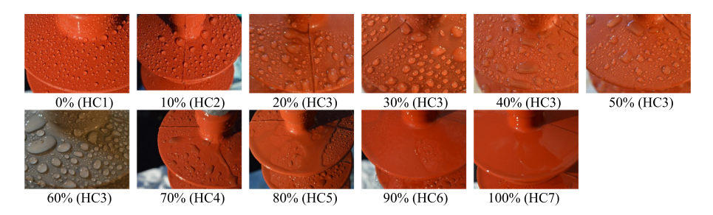Each class contains around 500 images, offering a fairly balanced distribution that helps avoid class bias during model training. The images were collected through controlled testing and various inspection scenarios to reflect real-world variability in surface conditions.

To train and evaluate the model, the dataset was split into 80% for training and 20% for testing, a common practice to ensure robust model performance and fair evaluation. The training set helps the CNN learn distinguishing features of each class, while the testing set assesses how well the model generalizes to new, unseen data.

This diverse and well-structured dataset plays a critical role in developing an effective image classification model for automated hydrophobicity assessment, and its size and quality make it suitable for TinyML optimization and deployment on resource-constrained edge devices.

**3.Proposed Design:**

The image illustrates the workflow of Hydrophobicity Classification using Transfer Learning and TinyML, inspired by a drone-based system. At the top, it contrasts traditional training from scratch—where a model learns to classify objects like dogs—against transfer learning, where a pre-trained model (originally trained to identify dogs) is reused and fine-tuned for a new task, such as identifying cats. In the adapted version for this project, a drone captures images of composite insulator surfaces, which are used to train a neural network.

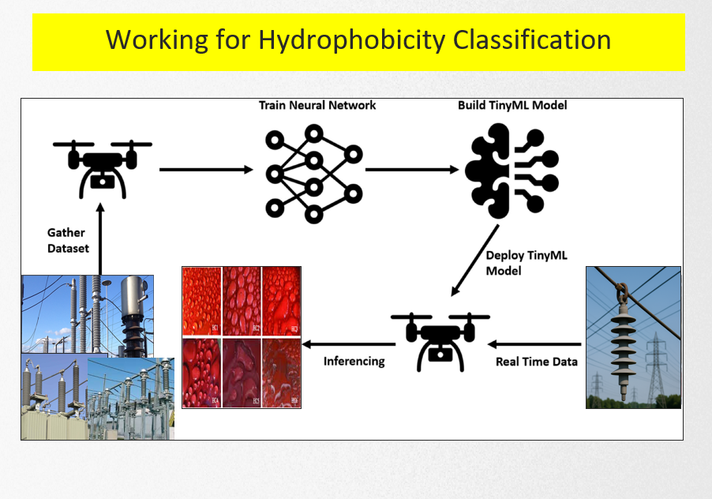Instead of training entirely from scratch, the process uses transfer learning, where a pre-trained vision model (such as MobileNetV2) is fine-tuned to recognize different hydrophobicity classes (HC1–HC7). This model is then optimized for deployment on resource-constrained TinyML devices like microcontrollers. The lower half of the image reflects this transfer learning approach, showing how the model trained on general features is adapted for the specific task of hydrophobicity classification, enabling real-time, on-device inferencing using drone-captured data.

**Fig6: Working**

* 1. 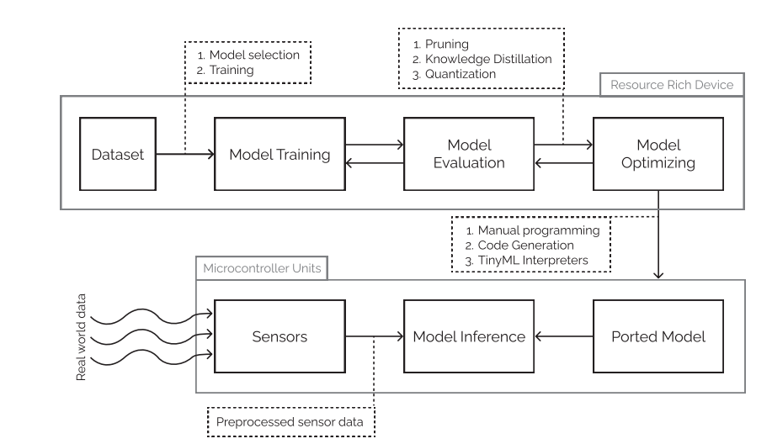 **Generic TinyML pipeline:**

**Fig7: TinyML pipeline**

This diagram provides a clear overview of the TinyML development workflow, showing how a machine learning model is trained, optimized, and deployed on microcontroller devices.

At the top section, the process begins with a dataset, which is used for model training. After training, the model is passed through the evaluation phase, where its performance is assessed based on accuracy, memory usage, and latency. Following evaluation, the model undergoes optimization using techniques such as pruning, knowledge distillation, and quantization to reduce size and computational cost, making it suitable for resource-constrained devices.

Once optimized, the model is ported to a microcontroller unit (MCU). The bottom section of the diagram shows how real-world data, collected through sensors, is pre-processed and fed into the ported model. This enables on-device inference, allowing the MCU to make predictions without relying on external computing resources.

Additionally, deployment includes methods like manual programming, code generation, or using TinyML interpreters, ensuring the model runs efficiently on the target hardware. This end-to-end flow demonstrates how powerful ML models can be adapted for edge devices in real-world applications.

**4. Model Training:**

The model training begins by selecting lightweight CNN architectures like MobileNetV2, EfficientNet-Lite, and SqueezeNet, which balance accuracy and efficiency. These models are initially pre-trained on large datasets such as ImageNet.

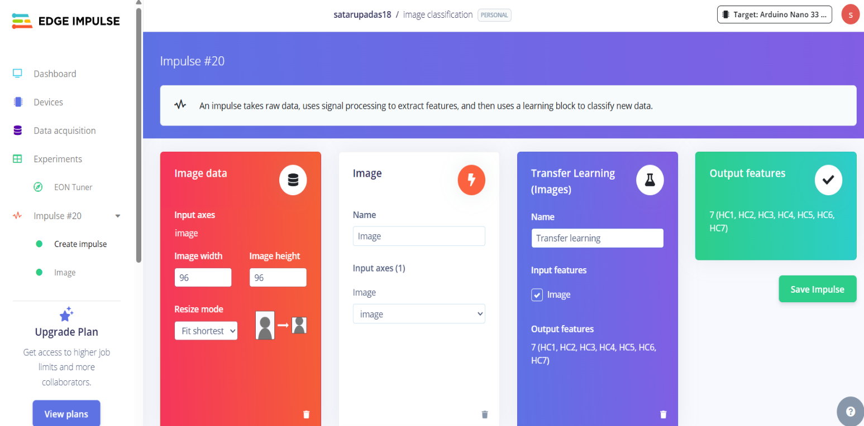Using transfer learning, the models are fine-tuned on the hydrophobicity classification dataset. Data augmentation techniques (rotation, flipping, brightness changes) help improve robustness and reduce overfitting.

**Fig8: Edge Impulse**

Training, optimization, and deployment are performed using Edge Impulse, a popular TinyML platform that simplifies building and deploying ML models on edge devices. Edge Impulse provides tools for data ingestion, model training with hyperparameter tuning, and automatic model optimization such as pruning and quantization.

After training, the optimized models are benchmarked for accuracy, inference time, memory usage, and flash size to ensure they fit within the resource constraints of microcontrollers before deployment for real-time, on-device inference.

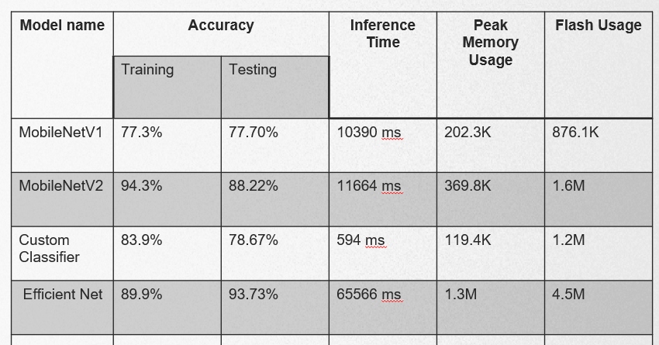**5. Model Evaluation:**

During evaluation, multiple lightweight CNN models were tested on the hydrophobicity classification dataset, focusing on metrics such as accuracy, model size, inference time, and memory usage.

* EfficientNet-Lite achieved the highest accuracy, demonstrating strong ability to correctly classify hydrophobicity levels.
* However, this improved accuracy came with a larger model size compared to other lightweight architectures like MobileNetV2 and SqueezeNet.
* The increased size means EfficientNet-Lite requires more memory and storage, which can be a limitation for deployment on tiny, resource-constrained devices.
* Other models offered a better trade-off between size and speed, but with slightly lower accuracy.

**6. Result Analysis:**

The evaluation showed a clear trend: as model size increases, accuracy improves. For example, EfficientNet-Lite achieved the highest accuracy among tested models but came with a significantly larger size and higher memory requirements.

Although popular MobileNet models are smaller and designed for mobile devices, they still exceed the memory limits of typical TinyML boards, making direct deployment challenging.

This highlights the need for model optimization techniques to bridge the gap between accuracy and hardware constraints. Methods like pruning (removing redundant model weights) and knowledge distillation (training a small model to mimic a larger one) help reduce model size and computational load while maintaining performance, enabling effective deployment on resource-limited TinyML devices

**7. Conclusion:**

This project focused on evaluating lightweight CNN models for classifying hydrophobicity levels of composite insulators on TinyML platforms. The results demonstrated that as model size increases, accuracy improves; however, larger models like Efficient Net-Lite are often too big for resource-limited devices. Smaller models such as Mobile Net are compact but still challenging to deploy directly on TinyML hardware without optimization. Therefore, techniques like pruning and knowledge distillation are necessary to reduce model size and computational demands while maintaining accuracy. These optimizations are crucial for enabling real-time, on-device hydrophobicity classification, supporting efficient and automated insulator monitoring in the field.

**8. Future Scope:**

In future work, I plan to explore advanced **model optimization techniques** such as **knowledge distillation** and **pruning** in greater depth. Knowledge distillation will be used to train smaller, efficient models that retain the accuracy of larger networks by learning from their predictions. Pruning techniques will help reduce model complexity by removing unnecessary parameters, further decreasing memory and computational requirements. Combining these methods aims to create even more compact and fast models suitable for TinyML deployment, enabling real-time hydrophobicity classification on highly resource-constrained devices with improved accuracy and efficiency.

**References**

* Christos-Christodoulos A. Kokalis, Thanos Tasakos,, “Hydrophobicity classification of composite insulators based on convolutionalneural networks”, Engineering Applications of Artificial Intelligence 91 (2020) 103613.
* Berg, M., Thottappillil, R., Scuka, V., 2001. Hydrophobicity estimation of HV polymeric

insulating materials development of a digital image processing method. IEEE Trans.

Dielectr. Electr. Insul. 8 (6), 1098–1107.

* Chen, X., Li, C., Huang, X., Zhao, L., Song, W., 2005. On-line estimating the level of hydrophobicity of composite insulators using the digital images. In: ProceedingsElectrical Insulation Conference and Electrical Manufacturing Expo. pp. 216–221.
* Deng, J., Dong, W., Socher, R., Li, L.-J., Li, K., Fei-Fei, L., 2009. ImageNet: A large-

scale hierarchical image database.

* Du, B.X., Liu, Y., 2011. Pattern analysis of discharge characteristics for hydrophobicity

evaluation of polymer insulator. IEEE Trans. Dielectr. Electr. Insul. 18 (1), 114–121.